Increasingly, animal shelters are no longer accepting feral cats for admission. Feral cats have coexisted with humans for thousands of years. Bringing these cats to the shelter results in their euthanasia, contributes to overcrowding at the shelter, and does not provide a long term solution to the problem – remove one cat, and another cat is likely to take its place. Just like wildlife such as raccoons and opossums, controlling food sources and using humane methods to deter cats is ultimately a more successful solution. When possible, trapping the cats and having them spayed/neutered further reduces problem behaviors, improves the cats’ health and welfare, and reduces their impact on wildlife.

What is a feral cat?
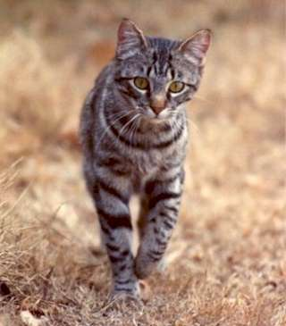
Feral cats are the same species as our pet cats. However, the difference is that feral cats have not had any contact with people, or, over time have lost contact with people. Many of these cats are born to former house cats, and some even used to be house cats. Whatever their origin, feral cats live outdoors “in the wild” surviving on their own, and in many areas will thrive in and around our neighborhoods. Some of these cats become accustomed to people and may be seen regularly frequenting certain areas, mainly where there is food and shelter for them, but most do not have owners. They are neighborhood cats. They are our community cats.

Feral cats are highly adaptable, which has helped in their survival over the last 10,000 years living alongside people. Since feral cats do not enjoy the company of people and do not do well indoors, they are not suitable for adoption. When brought into an animal shelter, feral cats are almost certain to be euthanized. However, left in their natural habitat, these cats can benefit us by providing for natural rodent control. Simple steps can be taken to prevent cats from becoming a nuisance.

I don’t want feral cats in my yard. What do I do?
Like other animals, feral cats are generally attracted to a location because it provides a source of food or shelter. Simple measures, such as removing food sources and blocking access to hiding places, can be helpful. Talk to your neighbors too – if they are feeding cats, share the resources below on how to properly care for feral cats while limiting the impact on neighbors and wildlife. In addition, there are a number of humane cat-deterrent products on the market, most of which can be purchased online or at lawn and garden supply stores.

Here is a list of a few of the popular deterrents:

Scarecrow: This motion-activated sprinkler responds to movement with an infrared sensor, and releases a three-second blast of water. Works on a 9-volt battery and covers an area approximately 45’ x 35’. Manufactured by Contech. https://www.ortho.com/en-us/products/garden/scarecrow-motion-activated-animal-deterrent

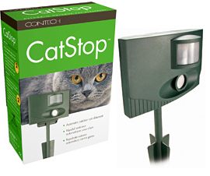
Catstop: This motion sensor activated deterrent emits a high-pitched, ultrasonic alarm that cannot be heard by humans, but will frighten cats and small dogs. Covers about 260 square feet and requires a 9-volt battery for operation. Manufactured by Contech. https://www.odordestroyer.com/product/CAT001.html
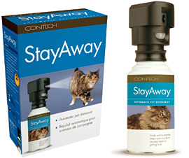
StayAway: This motion sensor activated deterrent delivers a burst of “compressed air” and an alarming sound. Comes in a refillable canister of “compressed air.” https://www.odordestroyer.com/product/stayaway001.html

CatScat: This non-chemical deterrent consists of a plastic mat with prickly plastic teeth that is pressed into the soil. These mats are annoying to cats, but they are safe and discourage defecating in the garden. (Many sources, just type “cat scat” into your search engine or ask at garden supply stores.)
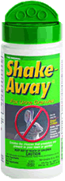
Shake-away: This safe and nontoxic granular deterrent contains the scents of fox, bobcat and coyote, which are animals that prey on cats. Must be reapplied regularly to remain effective. https://www.critter-repellent.com/domestic-cats-repellent

Other Ideas for Cat Deterrents:
- Concrete pavers, river rocks, large pinecones, or large bark to cover soil in planters or flowerbeds, to discourage cats from eliminating in these areas.
- Plastic runners (spike-side up) or chicken wire (sharp edges bent down) can be covered lightly with soil to discourage digging and eliminating in soil.
- Plant decorative herbs and perennials in your yard that some cats may find offensive: rue, scaredy-cat coleus (Coleus canina), marigolds, lavender, geranium, petunia
- Sprinkle cayenne pepper, coffee grounds, pipe tobacco, lemongrass oil, lavender oil, citronella oil, eucalyptus oil, or mustard oil on the ground to deter cats.
- Scatter fresh orange or lemon peels to deter cats.
Other Ideas for Cat Deterrents (cont’d):
- Embed wooden chopsticks with the dull side down into the ground 8” apart with the tops exposed.
- Establish a litter box in a designated area of the yard with soil or sand. Keep it clean and free of deposits to encourage its use.
- Lawn and garden stores have many other animal deterrent products.

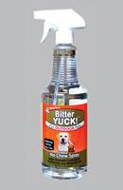
Odor Control:
- NaturVet Yard Odor Eliminator: This is a nontoxic odor eliminator that is safe to use on grass, plants, patios, concrete, fences, etc. https://naturvet.com/product/yard-odor-eliminator/

Feral cats should not be relocated outside their natural range
(no more than 200 feet, or about 2/3rds of a city block).

Please keep in mind that the cat that seems feral
might be somebody’s pet, and as such, their personal property.

California Laws
- Willful abandonment of an animal is prohibited. (Penal code section 597s).
- It is illegal to intentionally kill an animal. (Penal code section 597)
- Poisoning of animals is specifically prohibited. (Penal code section 596).

I don’t mind having feral cats around, but I’m worried about them. What should I do?
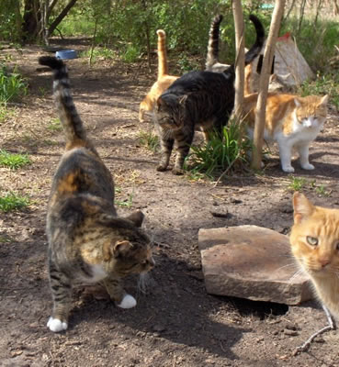
Becoming a caregiver for neighborhood cats, whether it’s a single cat or an entire feral family unit that has “adopted” your property as home, can be an extremely rewarding experience in providing these cats with a safe and secure place to live. Keep in mind that if you feed feral cats, it is important to also get them spayed/neutered so they don’t continue to reproduce. By being mindful of the needs of the cats, while maintaining good terms with your neighbors, caregivers can set a great example for others in the neighborhood to help understand and peacefully coexist with neighborhood cats.

There are many websites that can assist caregivers with feeding strategies, building shelters and litter boxes.

Here are just a few:
- Alley Cat Allies Providing Food and Water: https://www.alleycat.org/community-cat-care/food-and-water-tips/
- Alley Cat Allies Providing Shelter:
https://www.alleycat.org/community-cat-care/providing-shelter/
- Alley Cat Allies Helping Cats and People Co-exist: https://www.alleycat.org/community-cat-care/how-to-keep-community-cats-in-an-area/

I would like to be a responsible colony caretaker. What do I do?
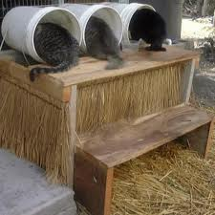

There are many different websites that can help with the care and management of neighborhood cat colonies, from how to set-up feeding stations, to communicating with your neighbors, to the best methods of trap, neuter and return (TNR). Below are a few links to some of the popular sites:

- Neighborhood Cats Managing a Feral Cat Colony: http://www.neighborhoodcats.org/
- Alley Cat Allies Colony Care Guide:
https://www.alleycat.org/community-cat-care-category/cat-care/colony-care/
- Cat Resource Center Feeding and Managing Colonies: http://www.catcenter.org/
- San Francisco SPCA Community Cat Resources:
https://www.sfspca.org/our-work/community-medicine/community-cats/community-cats-resources/

What is Trap-Neuter-Return (TNR)?
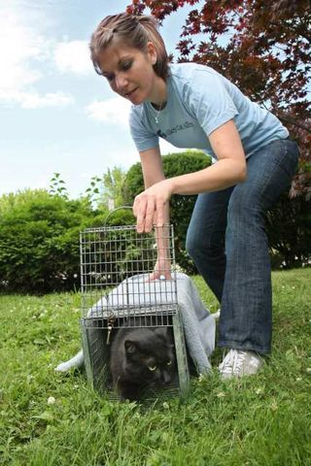
TNR is the most effective and humane method of managing community cat populations. It starts with the humane trapping of the community cat, spaying or neutering and vaccinating, then returning the cat to the same location where they were found. Cats that have been sterilized are “notched” in the ear (the very tip of one ear is surgically removed) to identify them as sterilized once returned to their colony. Spaying and neutering decreases unwanted behaviors associated with mating such as spraying, fighting and yowling. Returning community cats to their home allows them to live out their natural life in their own territory while breaking the breeding cycle, and slowly decreasing the population through natural attrition. Many TNR programs are started by community members interested in taking part in solving the feral cat overpopulation problems in their communities. To find out more, check out some of these helpful links:

- Alley Cat Allies How to Help Feral Cats: https://www.alleycat.org/community-cat-care/how-to-keep-community-cats-in-an-area/
- Best Friends FAQ’s on TNR:
https://resources.bestfriends.org/article/frequently-asked-questions-about-tnr
- San Francisco SPCA Trapping 101:
https://www.sfspca.org/sites/default/files/documents/cc_trap-101_final_0.pdf

Additional Resources

- Neighborhood Cats: http://www.neighborhoodcats.org/
- Alley Cat Allies: http://www.alleycat.org/
- Feral vs. Stray: https://www.alleycat.org/resources/feral-and-stray-cats-an-important-difference/
- Alley Cat Allies FAQs: https://www.alleycat.org/about/frequently-asked-questions-faq/
- Alley Cat Allies Community Cat Brochure: https://4fi8v2446i0sw2rpq2a3fg51-wpengine.netdna-ssl.com/wp-content/uploads/2016/09/TruthAboutCommunityCats_TruthCard.pdf
- Best Friends Animal Society Feral Cat Resources: https://resources.bestfriends.org/advocacy/community-cats
- City of San Jose (About Ferals):
https://www.sanjoseca.gov/your-government/departments/animal-care-services/stray-feral-cats-kittens
- The Cat Resource Center: http://www.catcenter.org/
- Town Cats (Feral Cat Resources):
http://www.towncats.org/towncats/feral-cats/
- San Francisco SPCA Community Cat Resources:
https://www.sfspca.org/resources/communityferal-cats/community-cat-resources

Published by the UC Davis Koret Shelter Medicine Program.
Visit us online at www.sheltermedicine.com

